Project Development Phase
DashBoard And Story

Date | 26 February 2026
Team ID
Project Name | An Exploration of Electricity Consumption Patterns
Maximum Marks | 3 Marks

DASHBOARD
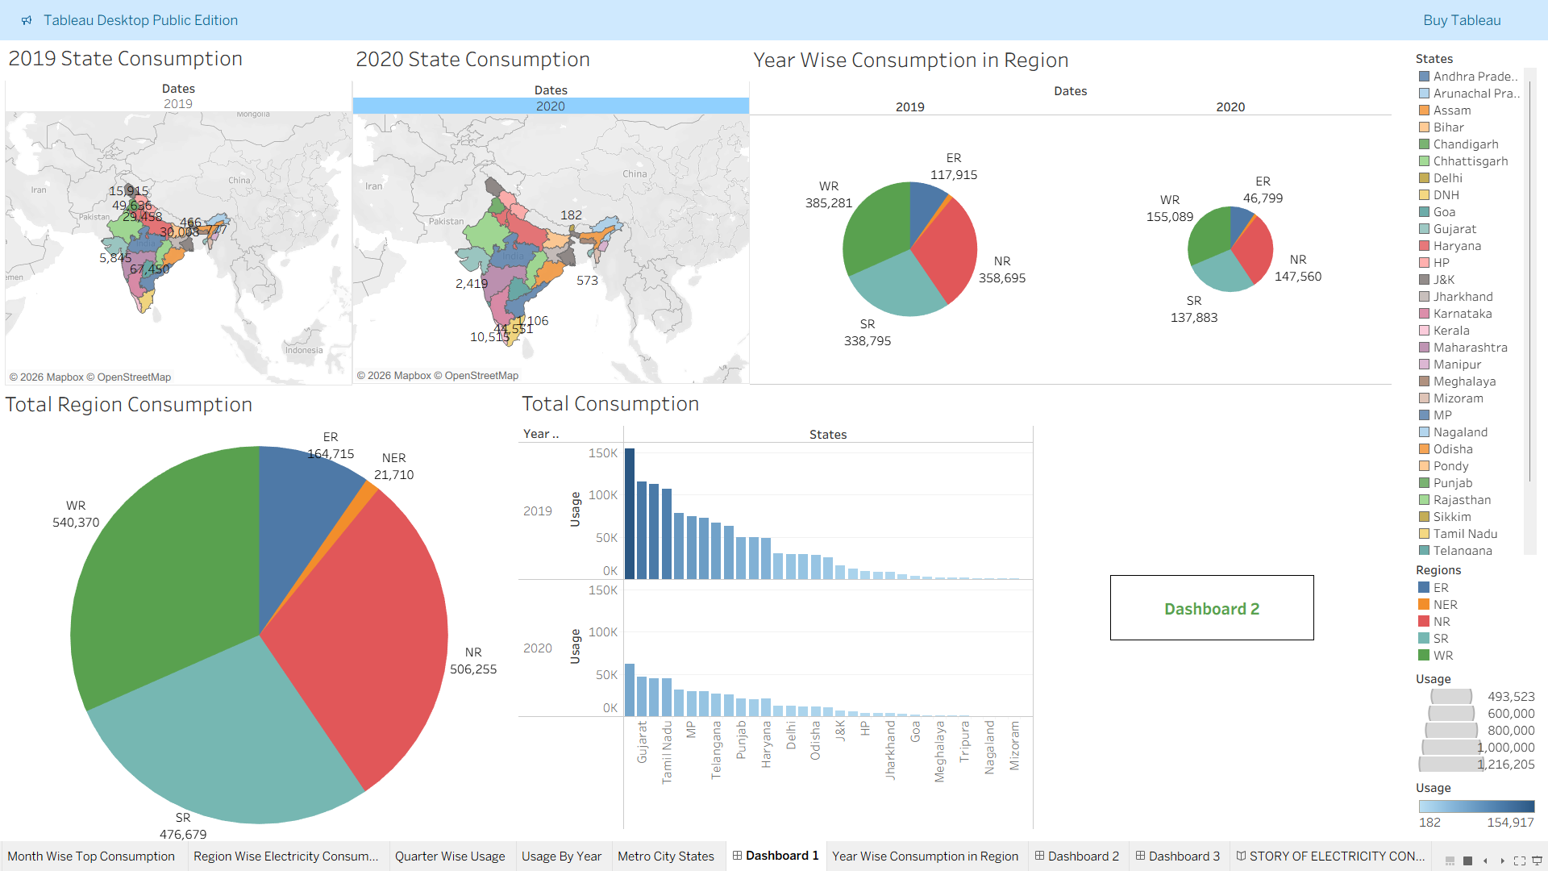

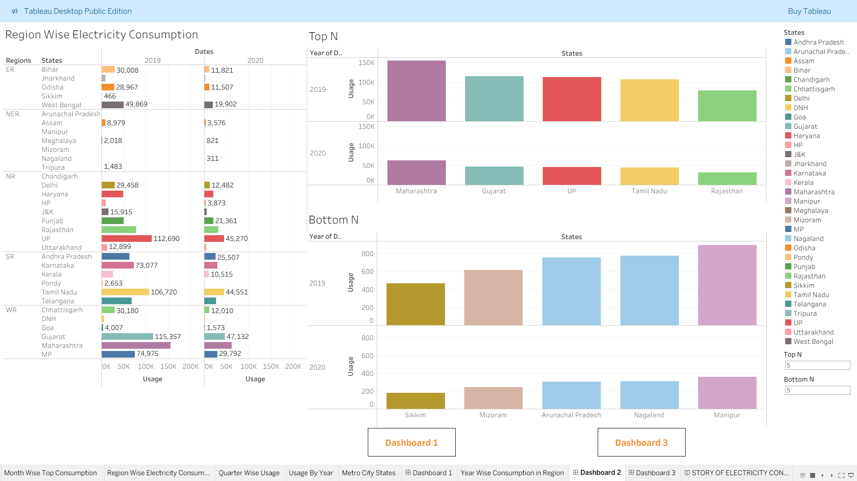

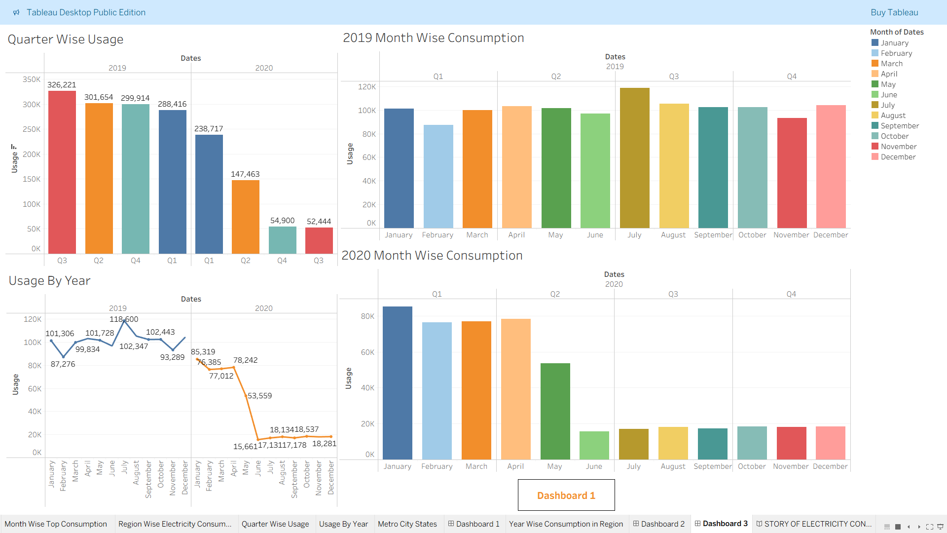

DASHBOARD PUBLIC LINK
https://public.tableau.com/views/ELECTRICITYCONSUMPTIONININDIA/Dashboard1?:language=en-US&publish=yes&:sid=&:redirect=auth&:display_count=n&:origin=viz_share_link
STORY
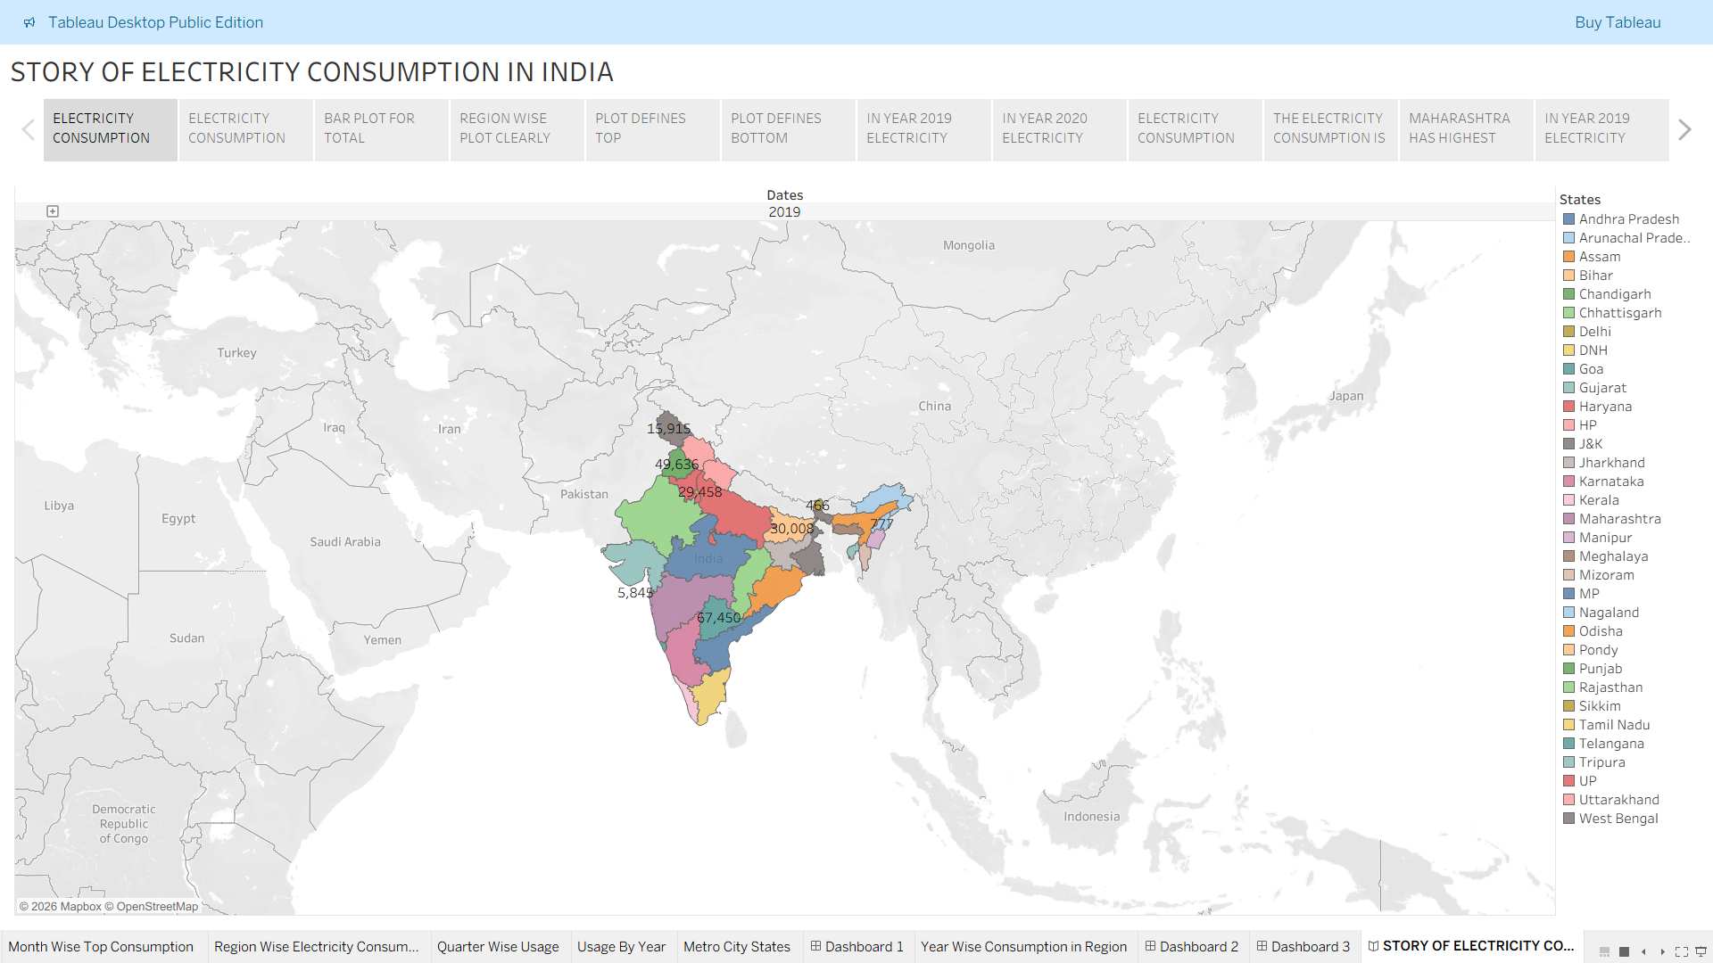
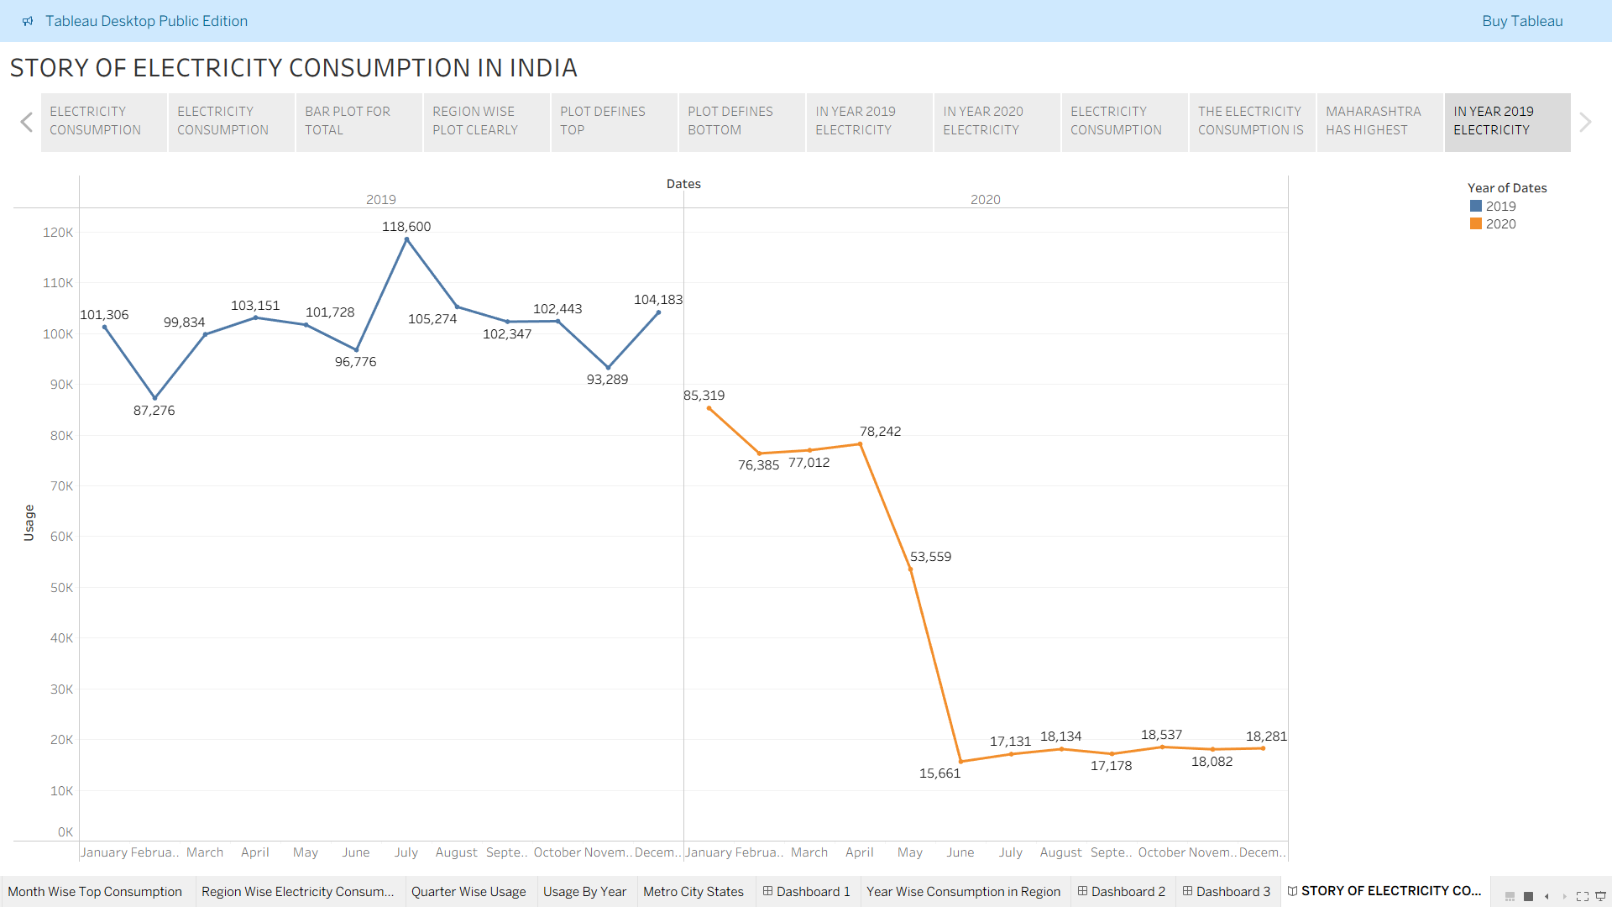

STORY PUBLIC LINK
https://public.tableau.com/shared/RTRWSFS4F?:display_count=n&:origin=viz_share_link

